MSP
Instructions on how to view MSP data
WWW.MYAEROSPACE.COM
USERNAME:
PASSWORD:
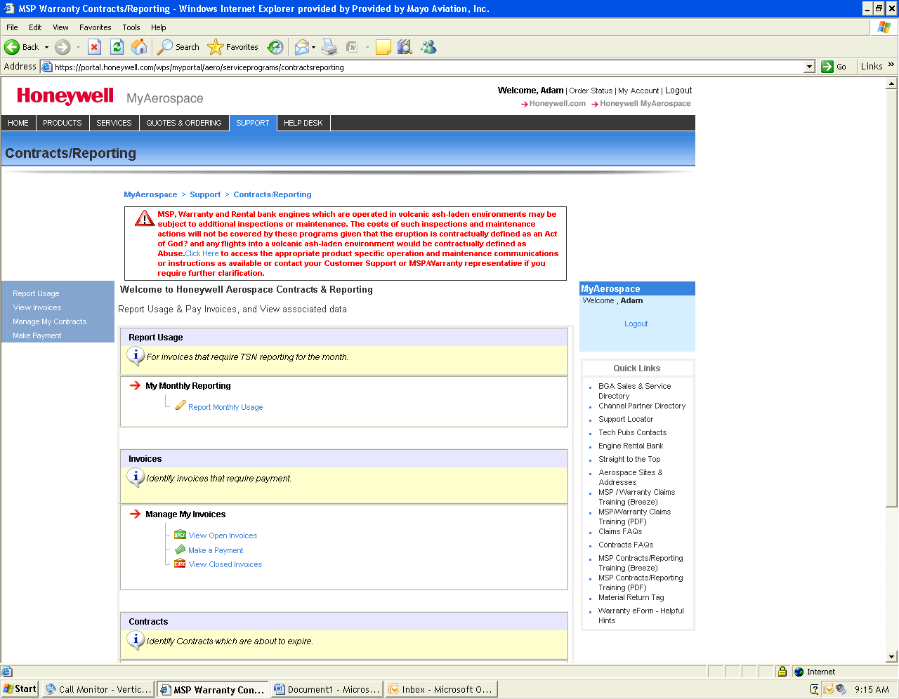
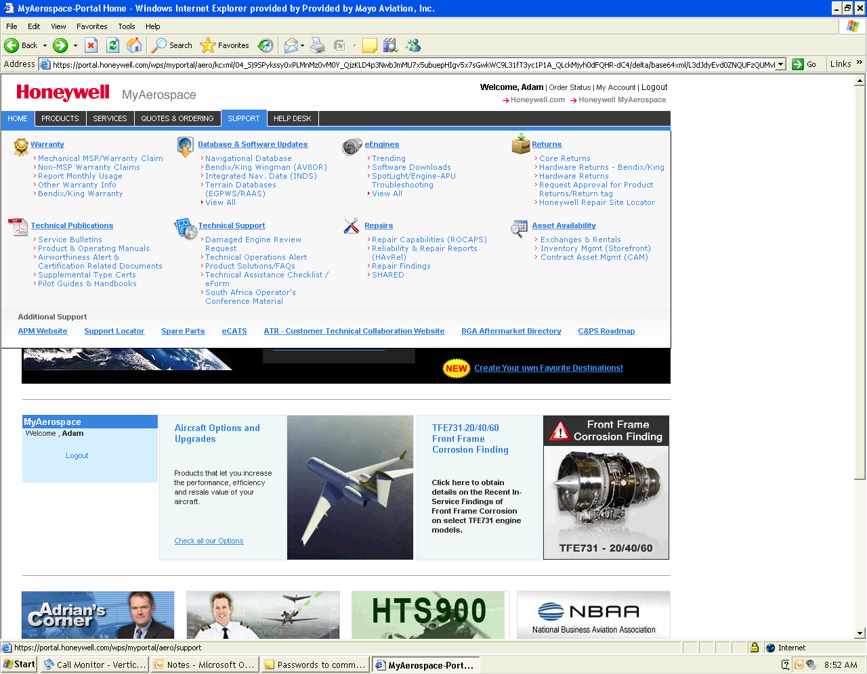
3) Choose what you would like to do
1) Click on “Support” tab
2) In the Warranty group, click on “Report Monthly Usage”

